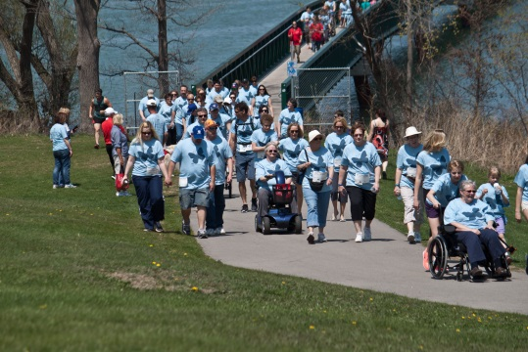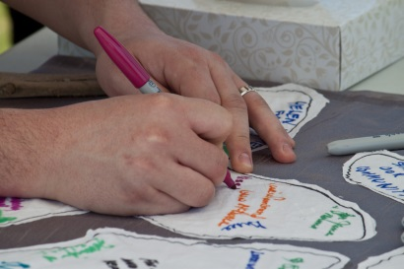

**13th Annual Hike for Hospice Niagara Raises $80,000 for Hospice Niagara**

On behalf of Hospice Niagara, we would like to thank everyone who joined us for a beautiful day on Sunday, May 3rd in the 2015 Hike for Hospice Niagara. This event is a community-wide occasion, bringing family and friends together to walk in honour and in memory of loved ones, and to raise funds, and awareness for Hospice palliative care in Niagara. Our hike took place at Lakeside Park in Port Dalhousie.

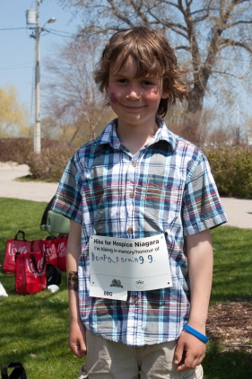This year, close to 400 hikers took part in our 13th Annual Hike for Hospice Niagara, and together we successfully raised $80,000 For Hospice Niagara’s programs and services. We here at Hospice would like to extend a heartfelt thank-you to all of our volunteers, sponsors, hikers, and to all those who contributed to the success of this year’s Hike for Hospice Niagara.

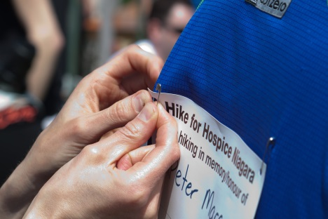

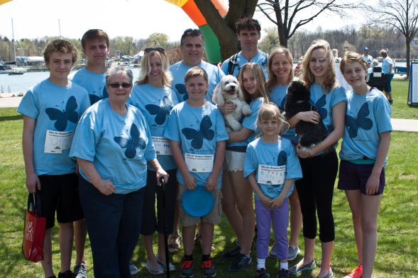

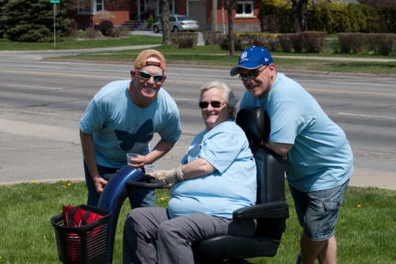

[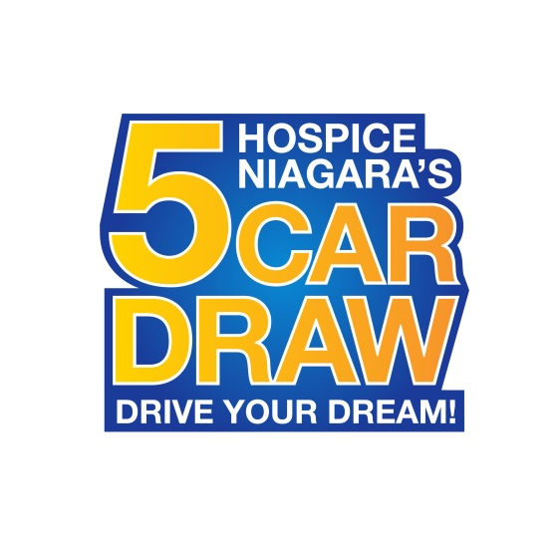](https://www.google.ca/url?sa=i&rct=j&q=&esrc=s&source=images&cd=&cad=rja&uact=8&ved=0CAcQjRw&url=https://www.hospiceniagara.ca/events/default/car_draw/&ei=SN1IVYTYA8z2yQTg1YCQAw&bvm=bv.92291466,d.aWw&psig=AFQjCNFLTdSY4ifdjcx6ZN-0vCgpgpgJEw&ust=1430924997110202)**5 Car Draw**This year, we have five brand new cars available to be won, 2015 Mazda 3 GX Sedan, 2015 FIAT 500 Sport 2dr Hatchback, 2015 Chevrolet Camaro 2LS, 2015 Ford F150 Crewcab 4x2 XLT, and 2015 Audi Q3.

Tickets are $25 each or 5 for $100. The final draw will take place on Monday, August 3th at 6:30pm during St. Catharines Rotary Ribfest at Montebello Park in St. Catharines. There is also a bonus Early Bird Draw that takes place at Niagara Falls Rotary Ribfest at the Niagara Square, in Niagara Falls on Sunday, June 14th 2015 at 5pm where one lucky winner will receive a 2015 Harley Davidson Dyna Street Bob. The early bird prize winner will also be eligible for the final draw. Only 20,000 tickets are available so don’t miss out and buy your 5 Car Draw tickets today!

Please visit 5cardraw.ca for more information about where to buy tickets or call Hospice Niagara at 905-984-8766.

**5 Car Draw ticket sellers needed**

Become a 5 Car Draw ticket seller and help raise valuable funds for Hospice Niagara’s

programs and services. We are looking for volunteers to help sell tickets to the public

at various festivals and events throughout the Niagara Region, as well as to sell tickets

to family, friends, co-workers, and neighbours.

If you are interested in supporting this exciting fundraiser, please sign up as a ticket

seller today. Also, pass this along to anyone that you think may be interested.

If 100 people sell just 10 tickets each, $25,000 will be generated for Hospice Niagara.

[Become a 5 Car Draw Ticket Seller today](http://hospiceniagara.ca/events/default/car_draw/)

**Save the date to join us:**

**Hospice Niagara’s 5 Car Draw**

Kicks off Sunday, May 3rd

Early Bird Draw - Sunday, June 14th at 5:00pm

Final Draw - Monday, August 3rd, at 6:30pm

5cardraw.ca

**Swing Hard to Live Strong**

18-hole golf tournament with great food, contests

and lots of prizes

Friday, June 26th, at 11:00am

Thundering Waters Golf Club

hospiceniagara.ca/golftourney

**TASTE of the Harvest**

Fabulous food and beverages with a casual

atmosphere and a spectacular view

Friday, September 11th, at 7:00pm

Mike Weir Winery

hospiceniagara.ca/taste

Swing Hard to Live Strong Golf Tournament

**Tournament Details:**

• Friday, June 26th

• Registration: 10:00am, Shotgun start: 12:00pm

• Includes green fees, cart, lunch, and dinner, great prizes, games and a silent auction

• Cost: $150 per golfer, $600 per foursome, charitable tax receipt: $50 per golfer

Register and pay by May 29th:

Come join us for a fun day of golf and good times in support of our programs and services. All proceeds from the golf tournament go directly to Hospice Niagara, and allow us to continue our programs and services. Please RSVP at your earliest convenience as this wonderful tournament will sell out quickly. See poster for further details.